**Performed steps**

1. Set up computer and load in simulation.
2. Insert different boat speeds.
3. Run the simulation for every boat speed.
4. Compare results with the corresponding outputs on the excel datasheet.

**Results**

This are the results with the simulation:

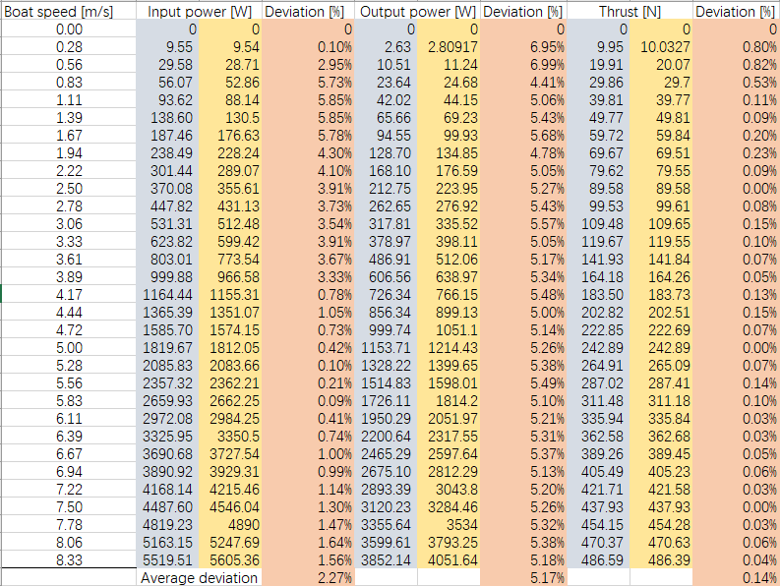



This picture shows the simulation results. Blue blocks contain real data, red block simulation results and yellow blocks contain deviation ratio. The deviation ratios of three outputs are all lower than 10%. And most deviations are lower than 5% which shows the system is reliable.

During the usage of simulation. After we input correct values and there are prompts to show successful simulation. When the wrong types of values are entered, there are warnings to remind users to input values in range and with right types of values.

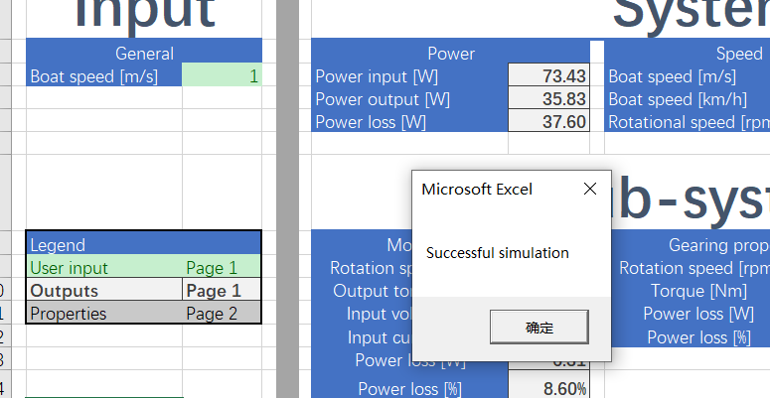

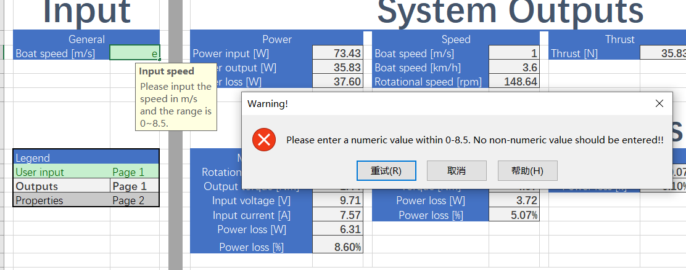

**Conclusion**

The results of this test meet the expectation of the desired results, with different inputs, there will be different correct corresponding input power, output power, and thrust. And all results have deviations less than 10%. Meanwhile, with correct inputs, there are prompts for successful simulation. And with wrong inputs, there are different warnings.